*DATA MINING*

*AND*

*WAREHOUSE PROJECT*

*Made By:-Nikhil chawla(18csu140)*

*Nikhil GArg(18csu141)*

**Project-1**

**Amazon Database**

Datawarehouse Diagram:-

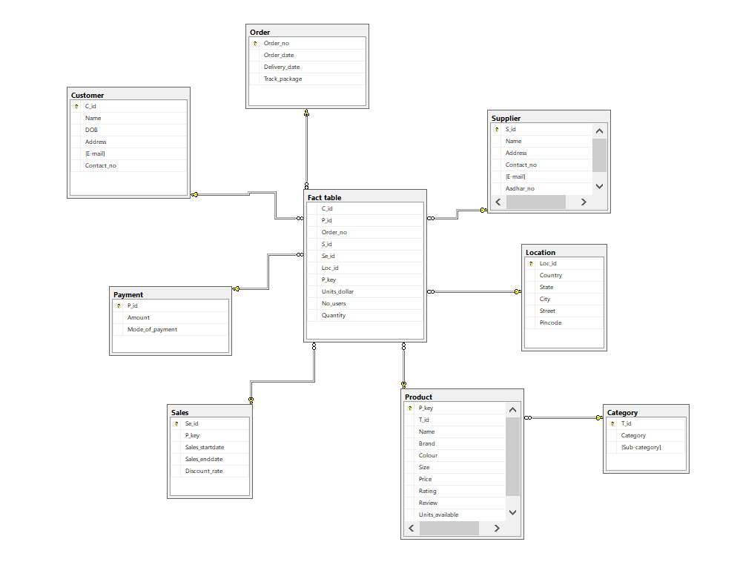

Order:-

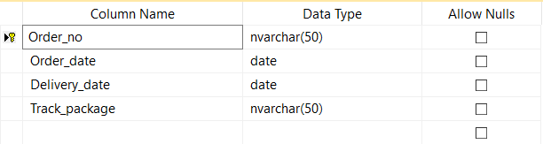

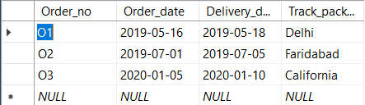

Customer:-

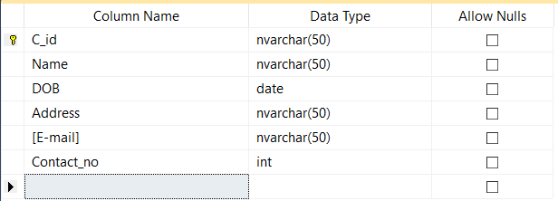

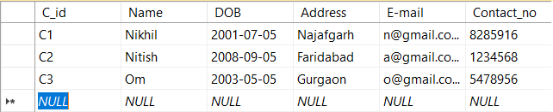

Supplier:-

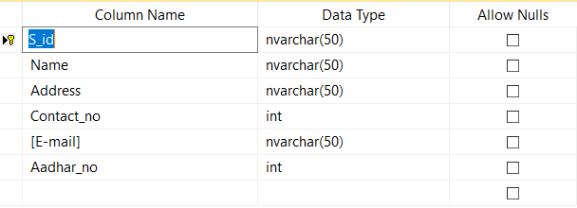

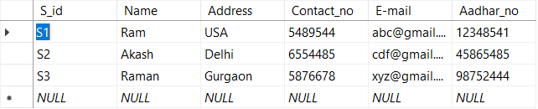

Location:-

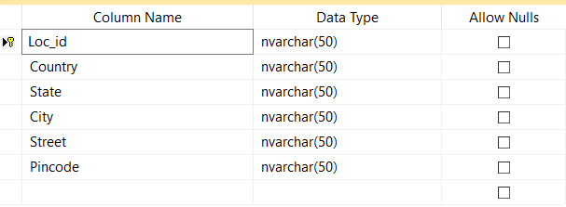

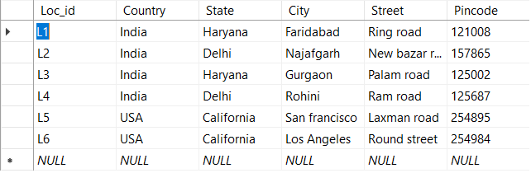

Product:-

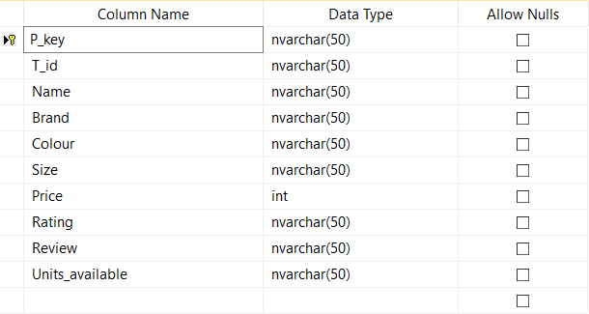

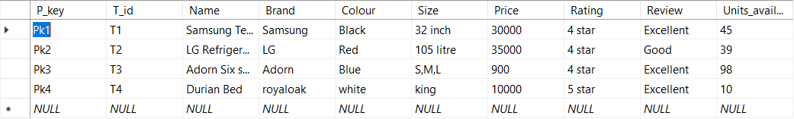

Sales:-

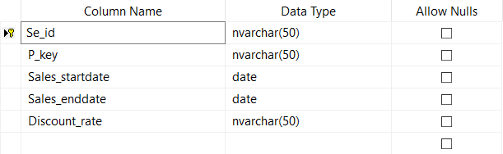

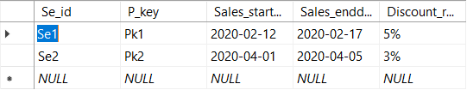

Payment:-

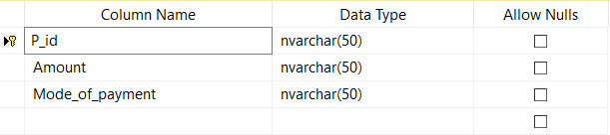

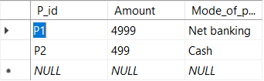

Fact Table:-

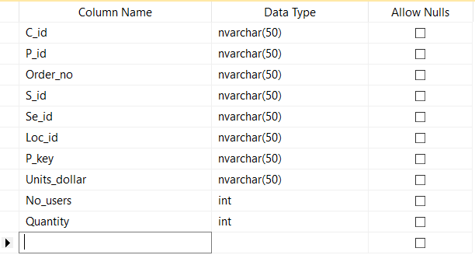

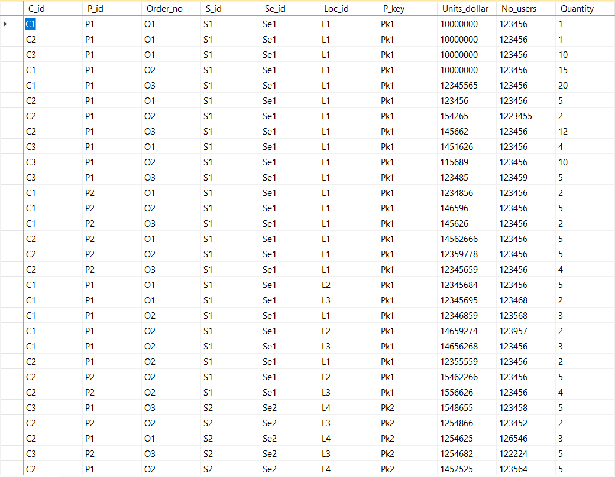

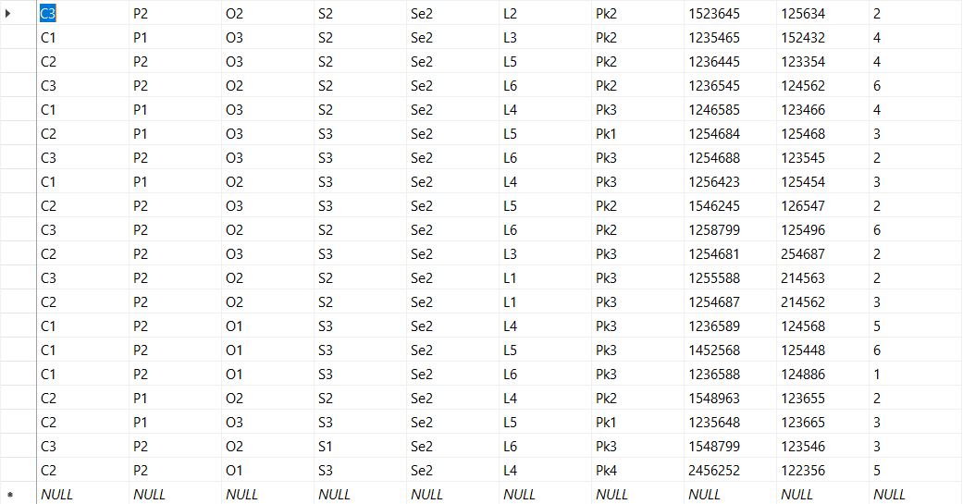

**Project-2**

**a)Weka Tool**

Dataset-Supermarket

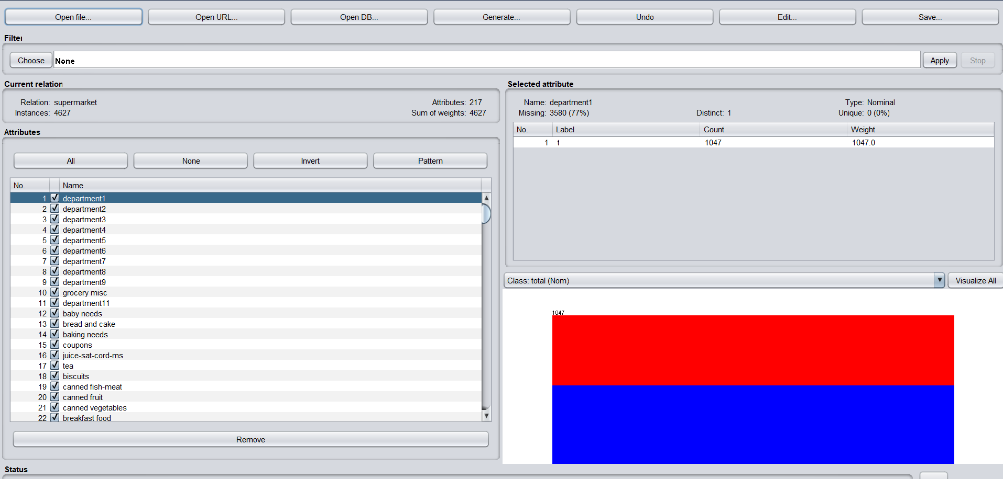

***APRIORI***

Configuration:-

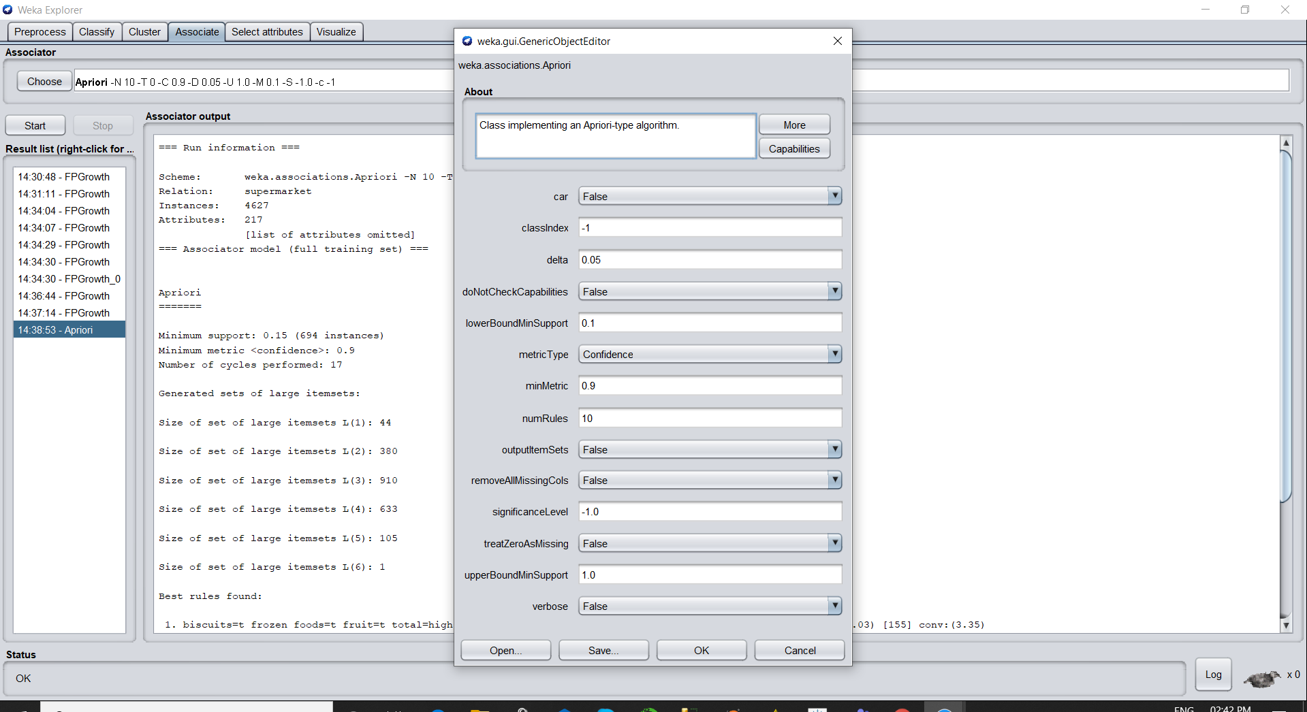

Association rule:-

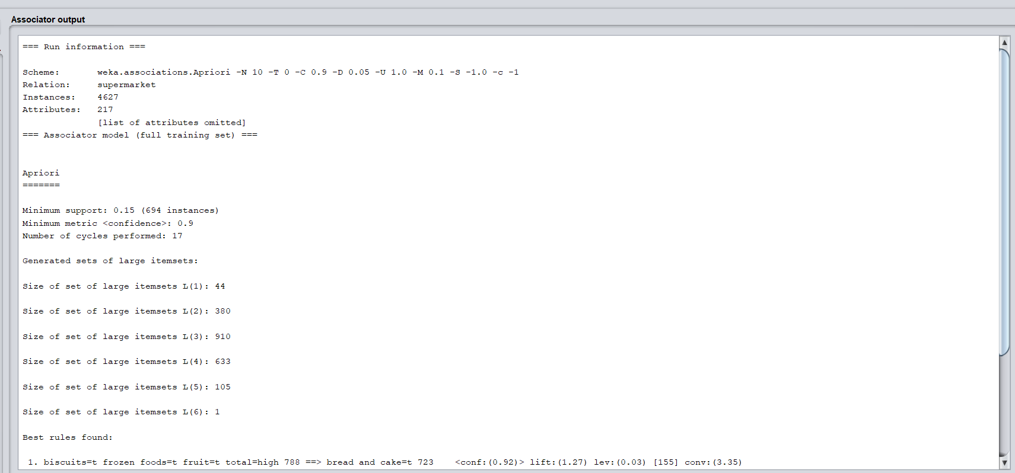

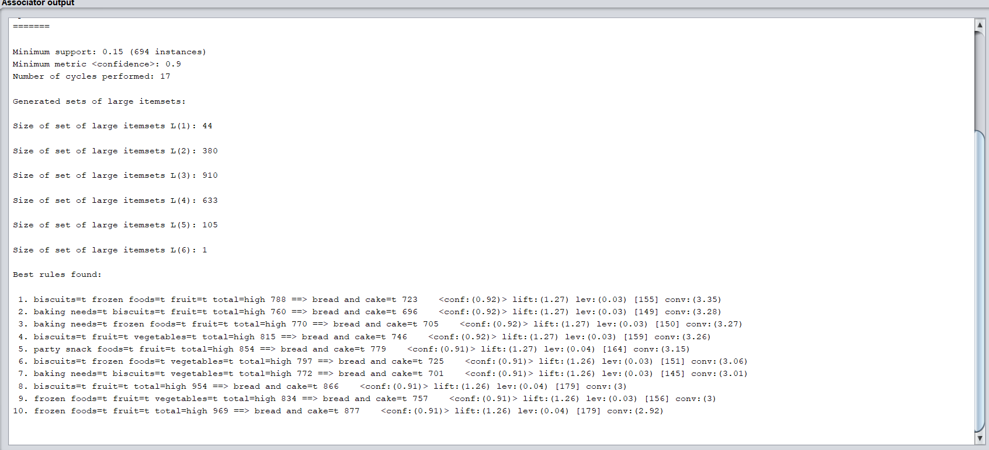

***FP Growth***

Configuration:-

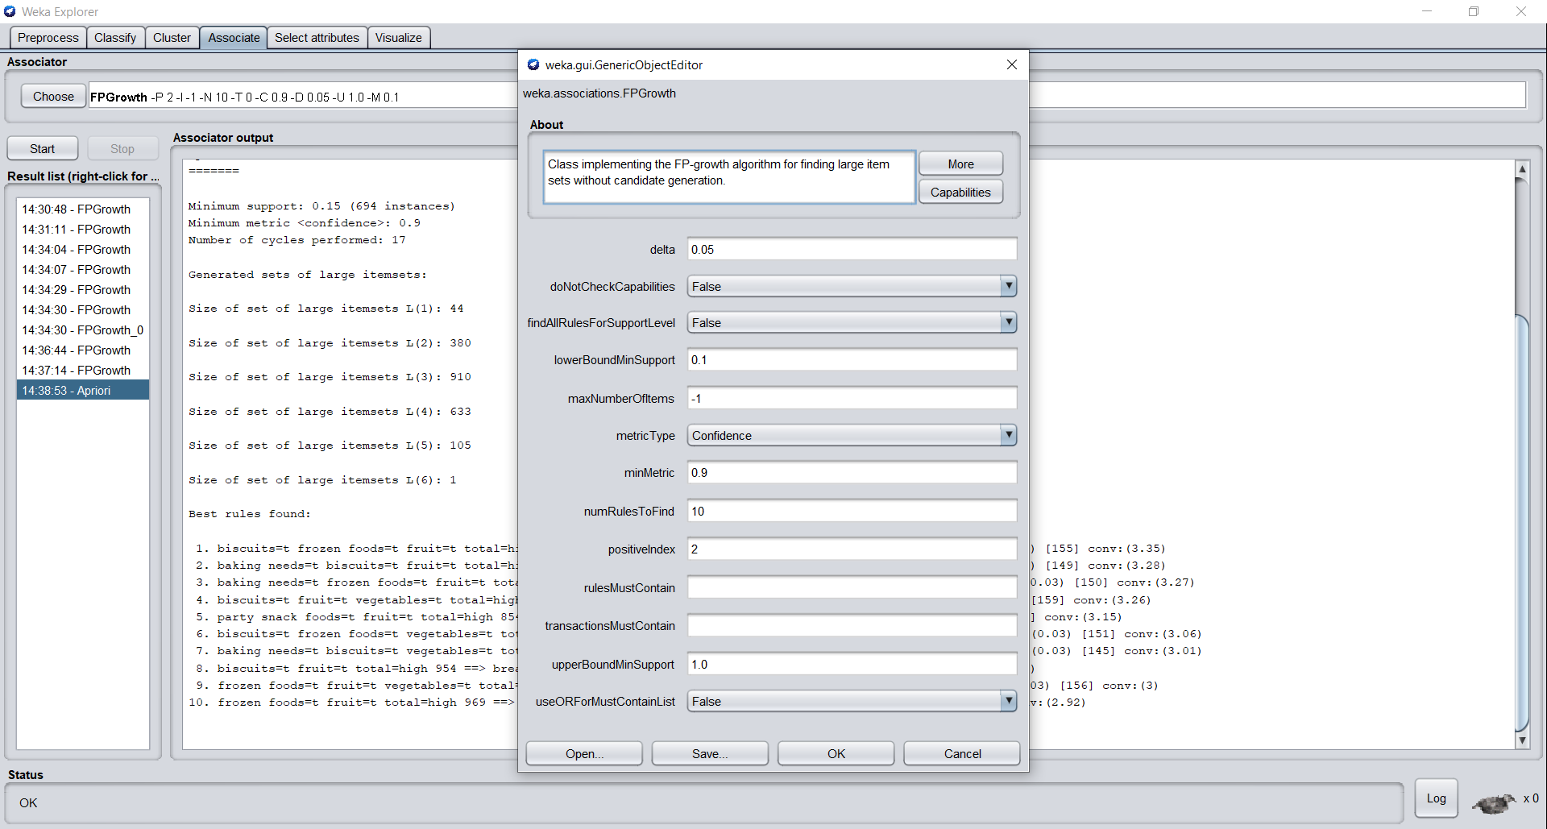

Association rule:-

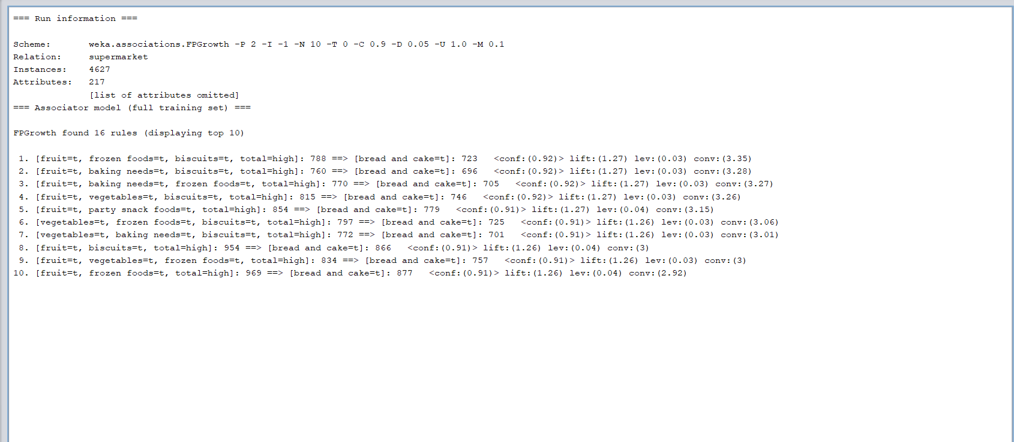

**b)Data Preparator:-**